For Immediate Release
March 11, 2025

Helmkamp Celebrates 87 Years of Excellence with a Strategic Succession Plan and Key Leadership Promotions

East Alton, IL – Helmkamp Construction Company is pleased to announce our long-term succession plan and three long-term employee promotions that will help drive the company into the future.

Helmkamp, a trusted name in construction for 87 years, has grown into a premier provider of construction services for industrial, building, and life science clients. The company’s enduring success is rooted in its dedication to safety, quality, and strong client relationships. As Helmkamp approaches nearly nine decades in business, owner Rob Johnes remains focused on proactively planning for the future.

Kyle Ogden has been promoted to President where he will oversee the day-to-day operations of the company as well as support business development, employee engagement, and long-term planning for the company. Ogden joined Helmkamp as a project management intern in 2007. He subsequently grew his career to Project Director, and then Vice President in recent years. He has made a strong and consistent contribution to the company's success over the last two decades with cross-industry projects, building client relationships, and as a mentor to the rest of the team.

“My goals for the company are simple… continue to provide the level of service and professionalism that both our long-term clients have become accustomed to and that which turns new clients into long-term clients. I also want to continue to perfect Helmkamp’s culture that has been built over our long history which results in Helmkamp teammates staying here for a long time. We have a great group of people here. I am excited about the opportunities we have in front of us and feel confident that the combination of these things will result in the continued long-term success for both our employees and our clients,” said Ogden.

Kyle Runge has been promoted to Vice President of Finance where he will manage the financial and accounting aspects of Helmkamp as well as the company’s human resources and information technology needs. Runge was hired in April of 2021 to fulfill the long-time role of former Helmkamp Vice President and head of accounting for 38 years, Gary Bradstreet. Runge has brought unparalleled value to the organization through best practices in finance, HR, and operations leadership.

Rob Johnes has been promoted to CEO where he will continue to stay involved with Helmkamp by mentoring employees and assisting business development and preconstruction efforts. Since 2012, Johnes has reinvested in Helmkamp and its people through the company’s unique 401k program, matching bonuses, competitive salaries, warehouse, equipment, training, and more.

“I am honored to have been the President of Helmkamp for the past 13 years and proud of the growth of the company and the employees during that time. I’m excited to see the next generation expand their leadership, continue to grow the company, and provide unapparelled opportunities for Helmkamp employees to be successful,” Johnes stated. “These promotions reflect our commitment to securing a strong future for Helmkamp.”

By remaining focused on leadership development and strategic succession planning, Helmkamp remains well-positioned for long-term success that ensures continuity for its employees, clients, and industry partners. The company looks forward to continued growth while maintaining the core principles that have made it a trusted construction partner for nearly nine decades.

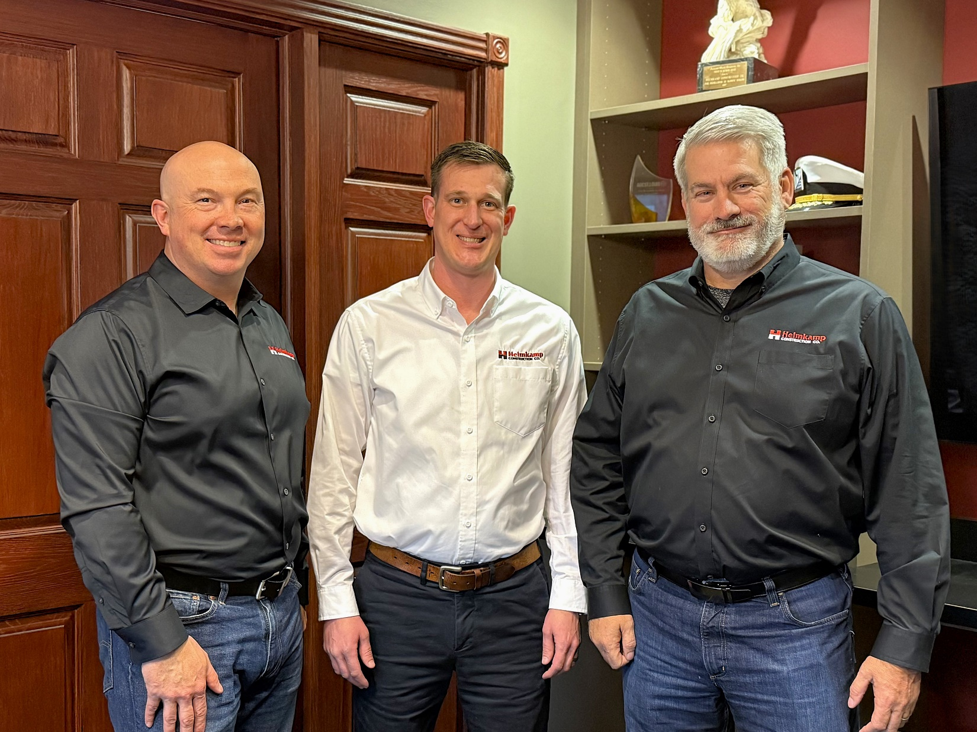
Pictured left to right: Kyle Ogden (President), Kyle Runge (Vice President of Finance), and Rob Johnes (CEO).

About Helmkamp
Helmkamp Construction Co. is the builder of choice for professional buyers of construction in Industrial, Building, and Life Science markets, primarily serving corporate clients in the St. Louis metro area. Helmkamp offers pre-construction, construction, and design/build services, as well as out-of-state capabilities. Since 1938, Helmkamp has built relationships based on quality, integrity, and safety leadership. To learn more, visit www.helmkamp.com.

Media Contact:
Jennifer L. Jackson, Marketing Director
Helmkamp Construction Co.
618.251.7085 | jjackson@helmkamp.com

